SYNOPSIS

**AutoHush - A mobile application**



**Group members :**

1. Sahil Lamba B7 - 13103649
2. Shaurya Sanger B2 - 13103471
3. Ajayveer Singh B7 - 13103418

**Project Summary**

Students/Working class/Corporate people in today’s world generally get disturbed by their phone while they are busy working. What if there were some app which could change the way their phone works when they reach different locations? *AutoHush* will be an android utility application that will provide the user the advantage of getting tasks done automatically when the device arrives at a particular location.



**Deliverables**

It will provide the following location based features :

* **Location based vibration (and also power on/off)** - Put your phone on vibration whenever you reach a particular location. So whenever a student enters his class his phone will switch to silent mode (or switch it off). Neither the teacher nor the class will get disturbed anymore!
* **Location based Wifi and Mobile data** - Switch on Wifi and automatically connect to the (remembered) Wifi router. So when one exits office, phone’s wifi will be switched off, mobile data will be switched on, and then when he reaches home, wifi will be switched on again.
* **Location based messages** - Send a message upon reaching your destination. *For example, “Reached sector 62, Noida”* like assuring your dear ones that you’ve reached your destination safely.
* **Location based reminders** - Reminding yourself about some work you were supposed to do upon reaching a particular place. *“Buy 1 kg apples, 2 litre milk, chocolates for son”* so that you don’t forget to buy these when you reach the market.
* **Location based Bluetooth** - Supposedly you have a bluetooth system in your car that you have to connect each time you use your car. Autohush will connect your bluetooth automatically as soon as you sit in your car. (assuming it’s usually parked at a particular location)
* Other location based features could also be added if time permits.

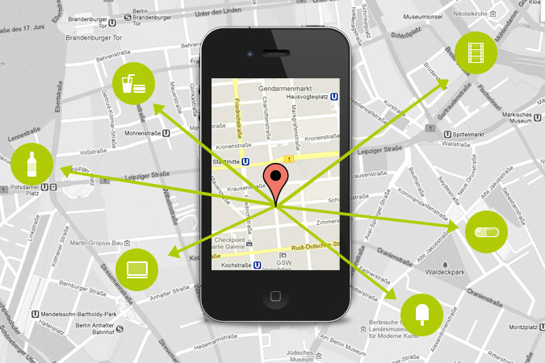

**‘Location’ will be our theme**. Using material design, the app will save a new ‘Location’ card (Latitude & Longitude coordinates) along with the required location based feature.

**Technical Details**

The app will be built in Eclipse IDE. It will be optimized for Android 5.1 Lollipop. Building the backend in Java, we will save the location and user data through either text files or SQLite database.

We will test the locations’ accuracy at different points, and will try to minimize the radius. After doing some research about Google Maps, we noted that the accuracy of android has improved a lot after Google Maps API v2 was released last year (hence we will be using the same).

**Benefits to the community**

With AutoHush, we’re basically trying to make things easier and faster. *'Auto’* means automatic and *‘hush’* means silently quick. With the emergence of smartphones in today’s world, we’re pretty sure that this app will be useful for a huge market. The app’s objective is such that people will use it on a regular basis.

